Technology Skills: CSS programming

Project: CSS Zen Garden

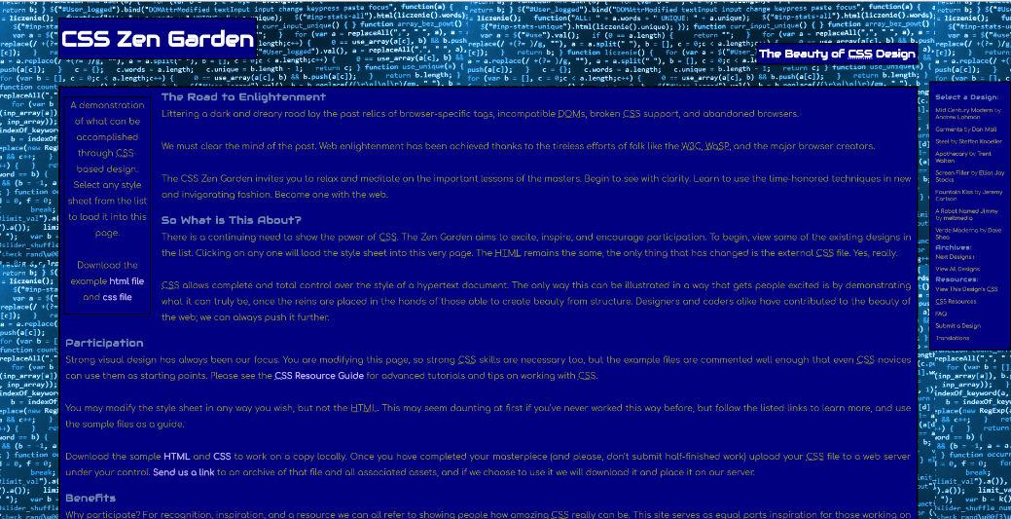

The CSS Zen Garden is a demonstration of various programmers showing off their use of CSS programming. Participants are given an HTML and a CSS file that creates a small web page. Once they make changes to the website, they can upload it to the CSS Zen Garden homepage for a chance of being featured with other winners. The beauty of the challenge is that the HTML is not touched at all. Each web page is created different solely through changing the CSS. My page isn’t award-winning material, but it represents one of the first times I used CSS on my own to create something.

The hardest part for me was thinking of a theme to base the website on. There are a thousand things I could have done better, but I settled on this blue coding theme. This page represents a learning experience early when I started learning how to code. I had good plans with my theme, but I was unable to present my theme in an interesting or good-looking manner.

As said before, this project was a learning experience for me. I was able to take what I learned about CSS and apply them to future projects. I learned how to manipulate images, fonts, and colors to specific part of a page. I was able to take this knowledge with me as I designed my future websites.